2015-2016 Activities

 | NAME OF THE ACTIVITY |  | DATE
1 | Awareness rally |  | 15-9-15
2 | Ozone day |  | 16-9-15
3 | Field trip |  | 28-11-15
4 | Guest lecture |  | 30-11-15
5 | Industrial trip |  | 1-12-15
6. | Guest Lecture |  | 27-12-15
7 | Extension activity- orientation programme |  | 7-1-16
8 | Student seminars |  | 7-11-15  5-12-15
10 |  | Group discussion | 7-12-15

Awareness rally- To use clay idols of Lord Ganesh to prevent environmental pollution. Students of I, II, III MZC participated in the rally displayed the ganesh idol made with mud and also students displayed placards showing the effects of chemical made idols.
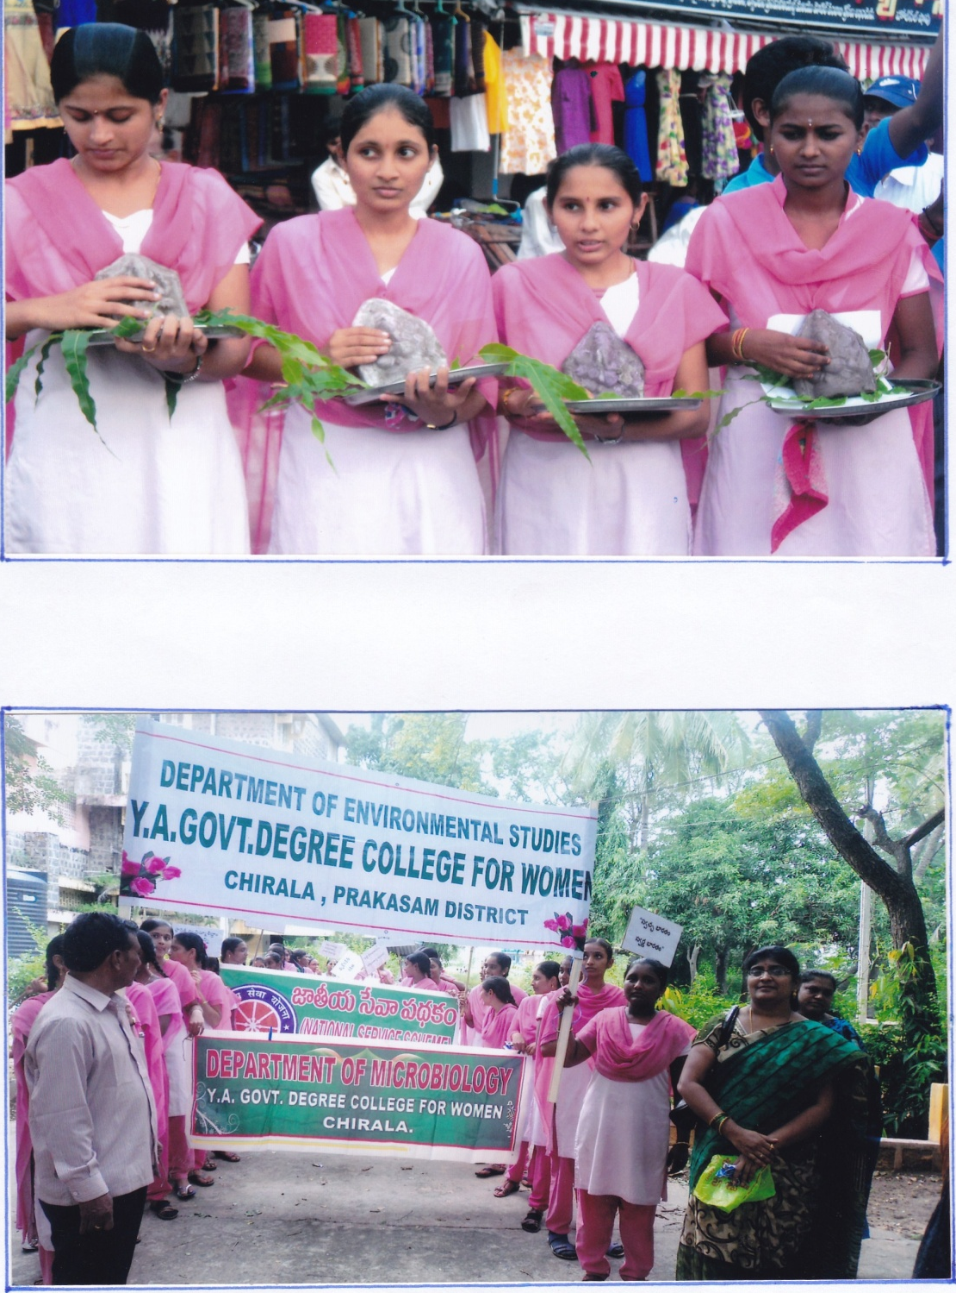
Ozone day: Ozone day was observed on 16-9-15 ,a rally was organized by all the departments in which students and the staff members participated in the rally . Students displayed the placards with the logos of ozone depletion and the protective measures to be taken.
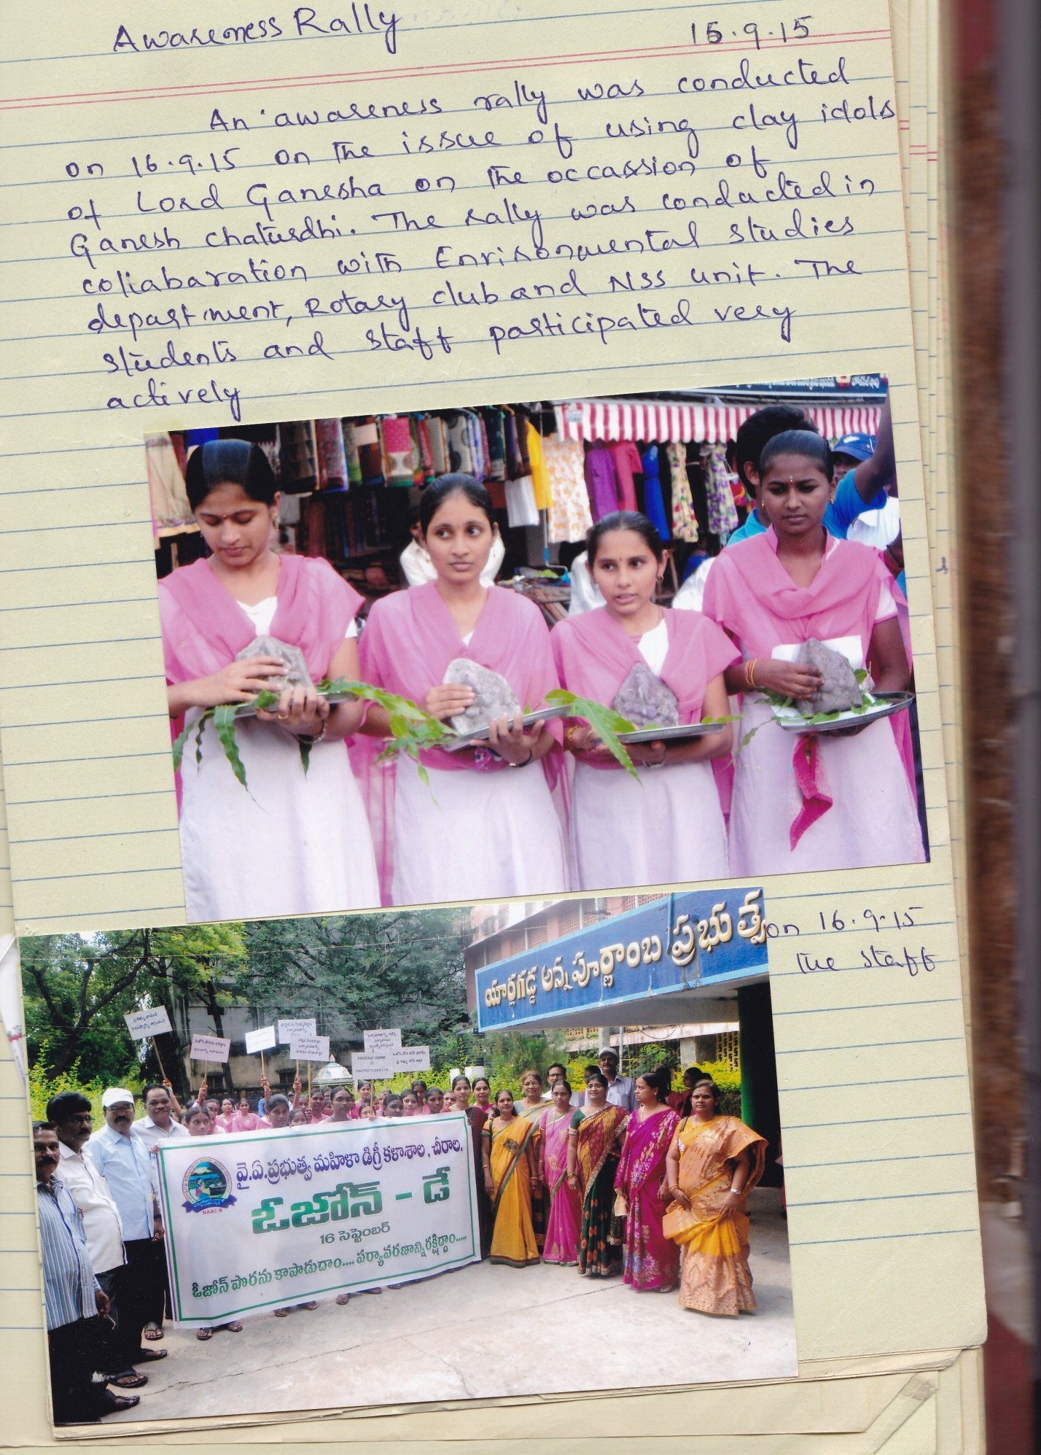

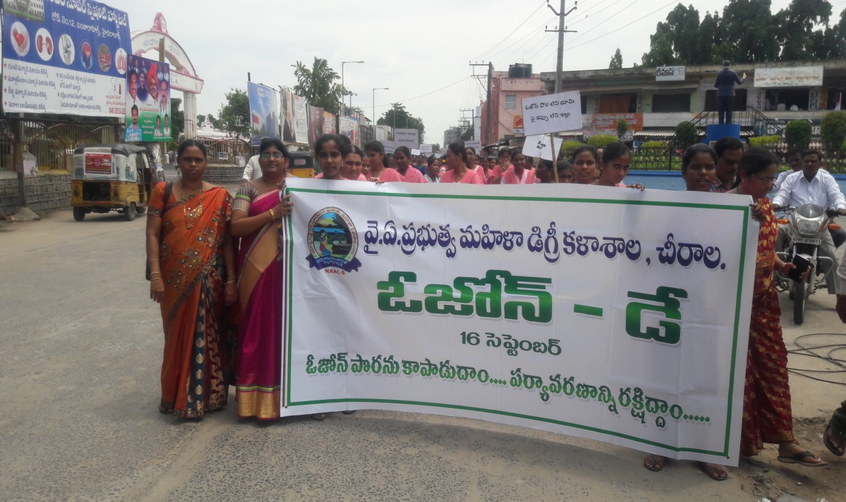

Field trip- A field trip was arranged to Apple Mushroom unit , Perala on 28-11-15 to the III MZC students where the students have learned the intrinsic and extrinsic factors required for the growth of mushrooms and also the measures to be taken for the crop management.
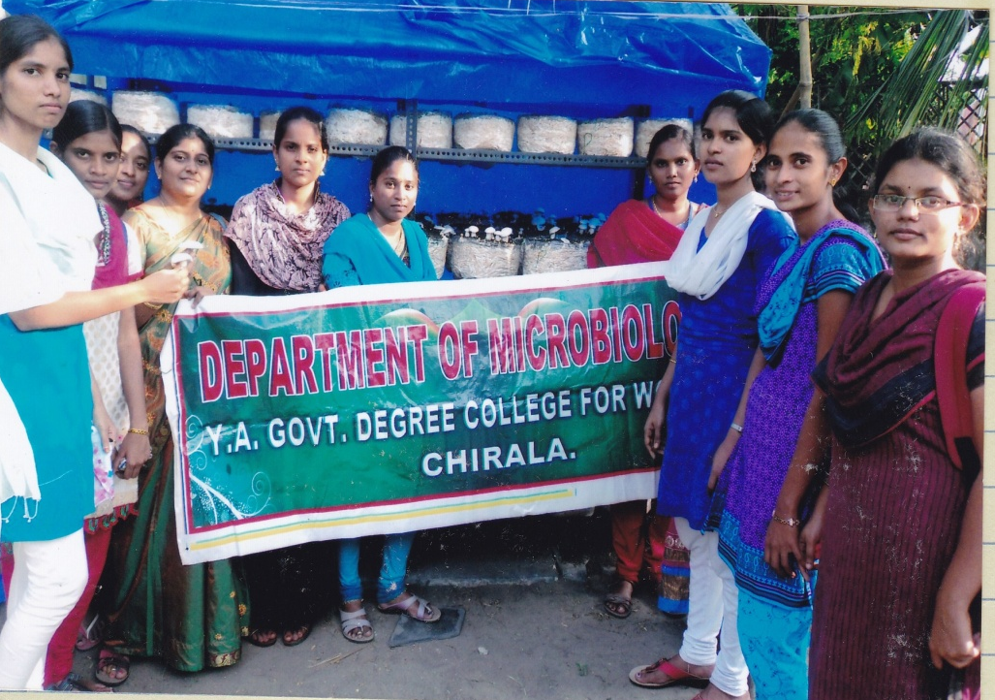

Guest lecture: A guest lecture was organized on” Ayurveda in treating infections” in collaboration with department of botany on 30-11-15. Sri S.V. Subba Rao from V.R.S & Y.R.N college acted as resource person and explained how the ancient wisdom of India has the power to cure so many infections caused by microorganisms.

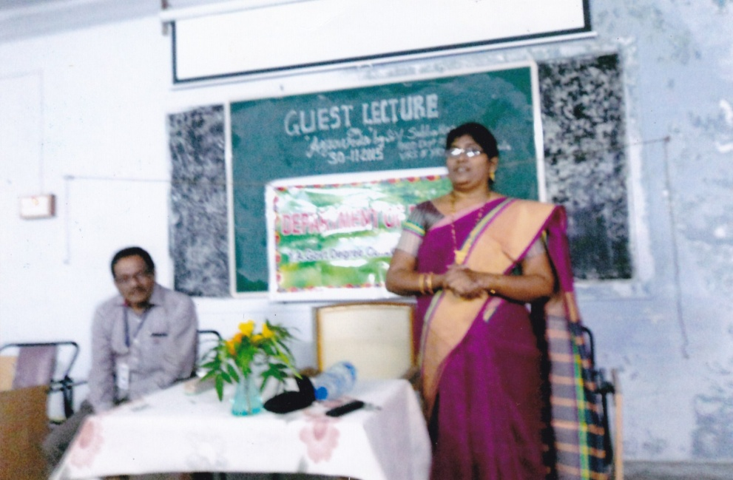

Industrial trip-Department of microbiology has arranged an industrial trip to Hindusthan Coca-Cola beverages private limited, Atmakur, Guntur dist on 1-12-15. Students have learned about the various procedures involved in coca-cola, thumsup and maza beverages preparation , visited Quality control and quality assurance departments.
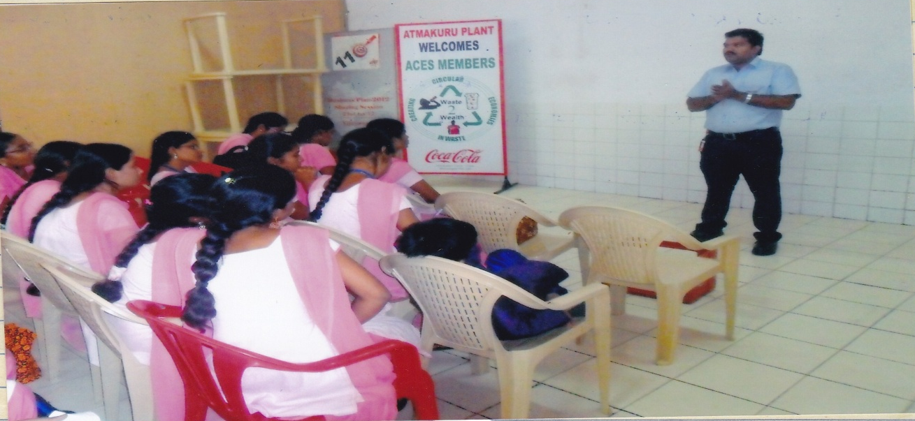

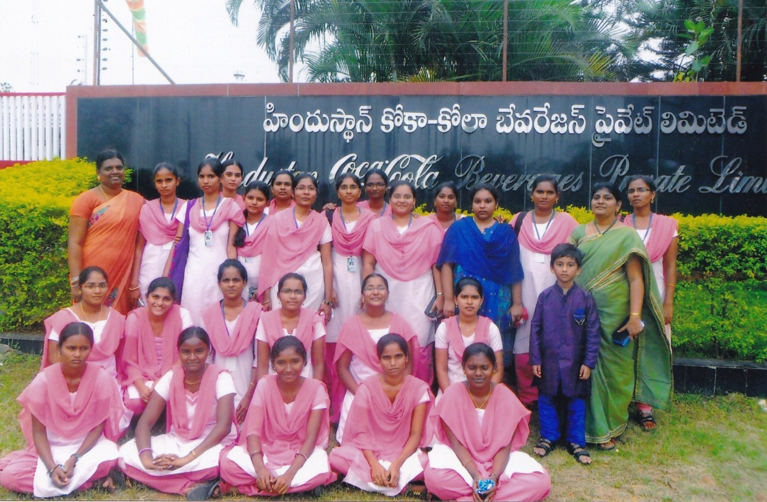

STUDENT SEMINARS: Department of microbiology has organized student seminars to I,II,III year students on 7-11-15 and 5-12-15.
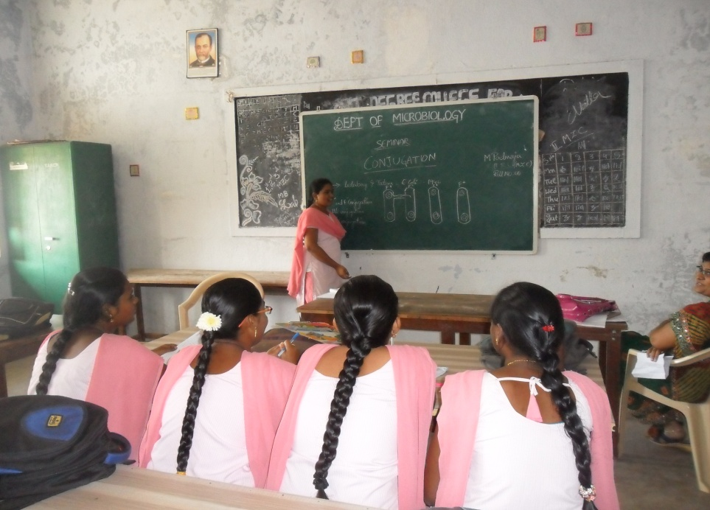

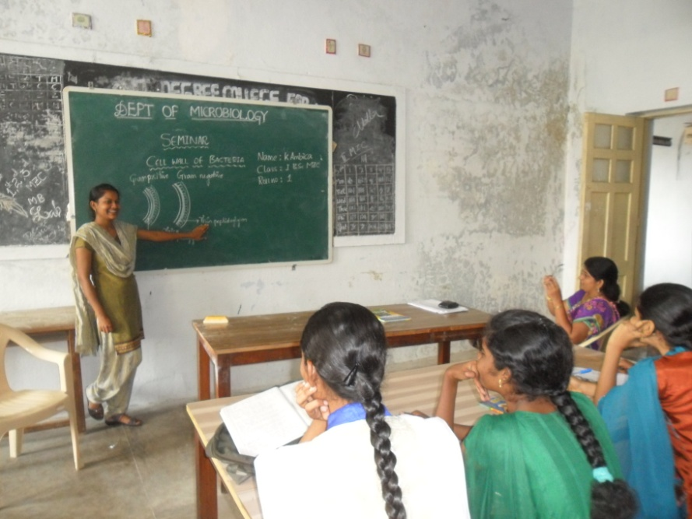

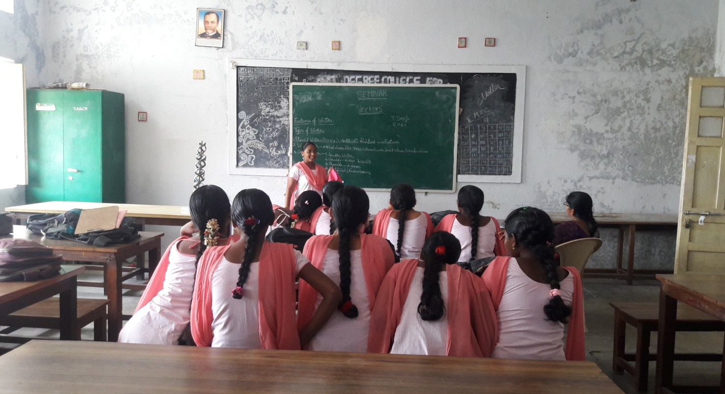

GUEST LECTURE: Department of Microbiology has arranged a guest lecture on 27-12-15.Smt Dr.T.Raja rajeswari , reader in chemistry , GCW(A) Guntur acted as resource person and delivered lecture on various chromatographic techniques. Doubts expressed by the students were clarified by her and the session was very much informative to the students.

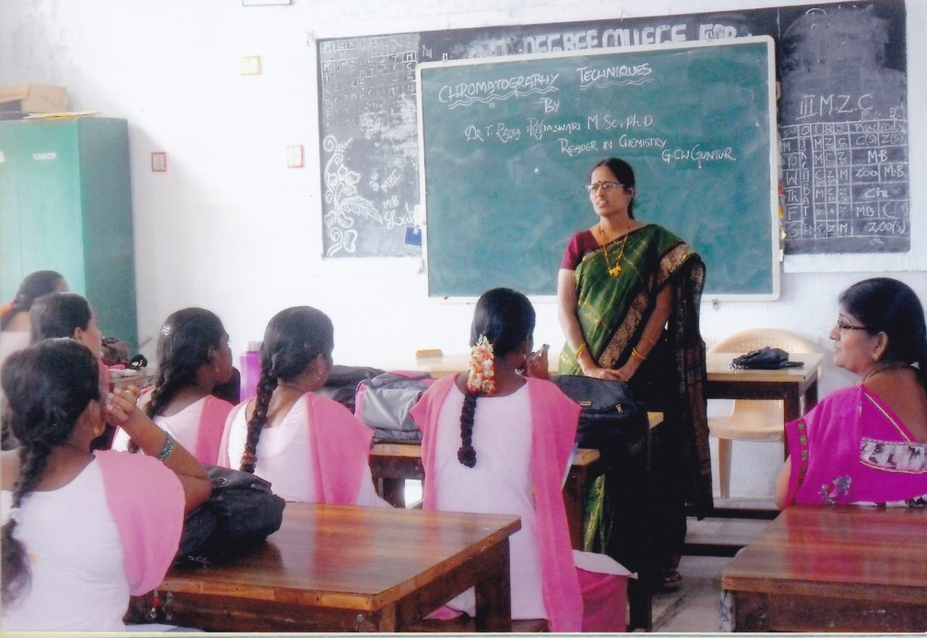

GROUP DISCUSSION: Group discussion was arranged to the II Year students on Drug resistance by Smt.N.Praveena Kumari on 7-12-15.

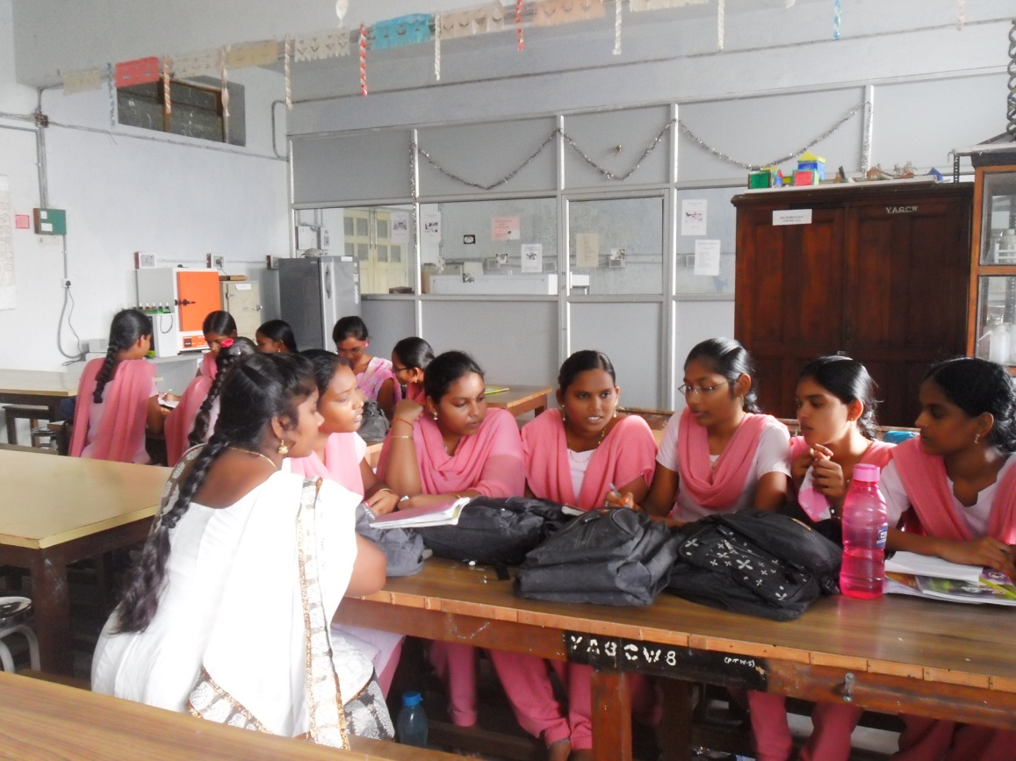

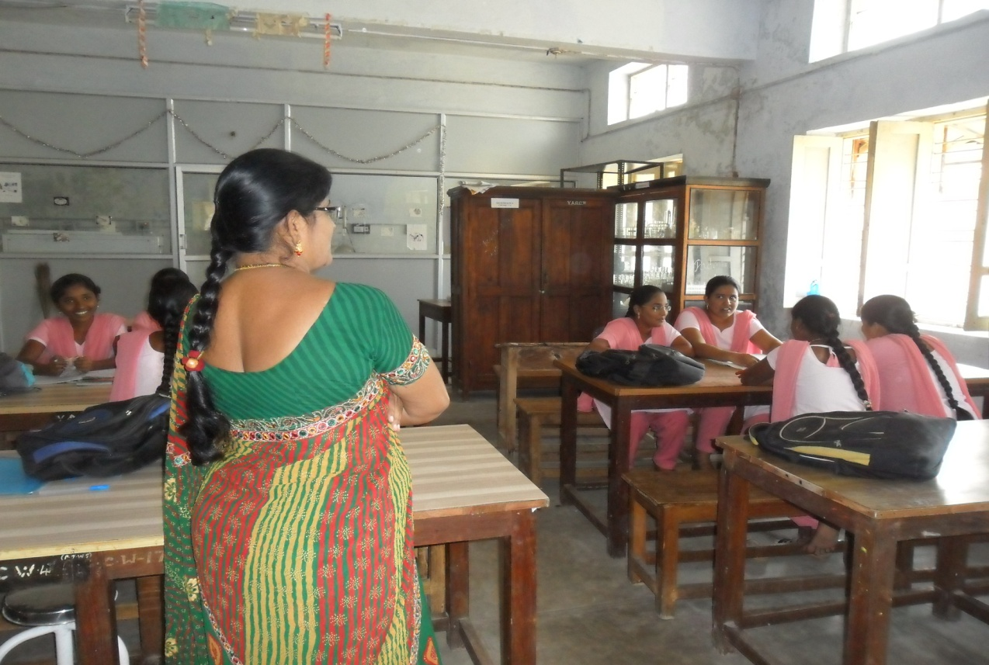

Extension activity- A orientation Programme was conducted to the school teachers on 7-01-16 to bring awareness about the equipment and handling of the instruments in the laboratory by RMSA.
